**Final Exam**

**Semester: Spring 23**

**Course: Data Structures and Algorithms II**

**Marks:30 Time: 1 hr**

[*Answer all the questions below*]

**Q1:** Show **step by step** calculation of shortest path from node ***0*** to ***6*** in the following

graph using Djkstra’s algorithm. [5]

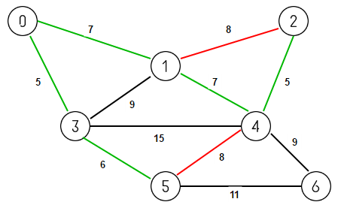

**Q2:** Show **step by step** calculation of minimum spanning tree in the following graph [5] using Prim’s algorithm.

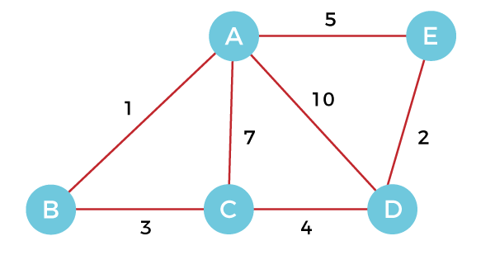

**Q3:** Draw the the tree for merge sort for the following array : [2, 20, 23, 5, 12, 9, 6] [5]

**Q5**: Find the LCS of these two strings: AGCAT and GAC. Show the computation in a table [5]

**Q6:** Given an amount *n* and the denominations of coins *c* available, determine how many [5]

ways change can be made for an amount. There is a limitless supply of each coin type.

**[Please see the next page]**

